RESUME

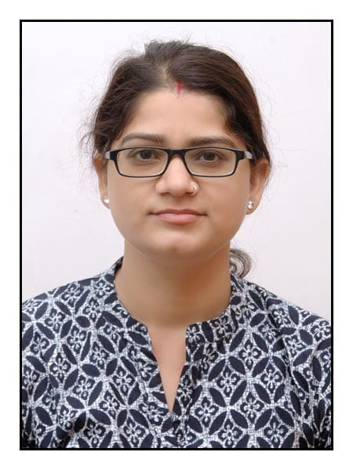
Name: Dr. Kiran Meena (M.Sc., NET, UGC-JRF, Ph.D) Designation: Assistant Professor
Address: Department of Chemistry
Mohanlal Sukhadiya University,
Udaipur-303001, India
E-mail: kiran02meena@mlsu.ac.in
Mob no: +91-9571365012
DOB: 02/04/1990

EDUCATION QUALIFICATION

Professional Qualification
Qualification | Subject | Year of Passing | % Marks and Division | Name of College/School | Name of University/Board
10th | All Subject | 2004 | 65.50 | Govt. Girls Sr. Sec. School, Mahwa (Dausa) | Board of Sec. Education Ajmer
12th | Chemistry  Biology  Physics | 2006 | 62.4 | Maheshwari Girls Sr. Sec. School, Choura Rasta, Jaipur | Board of Sec. Education Ajmer
B.Sc. | Zoology  Geography  Chemistry | 2011 | 70.0 | Kanoria College, University of Rajasthan, Jaipur
M.Sc. | Chemistry | 2013 | 58.7 | Chemistry Department, University of Rajasthan, Jaipur
Ph.D. | Chemistry | 2022 | - | Department of Chemistry | University of Rajasthan, Jaipur

Educational Qualification
- Qualified UGC-NET JRF test in Chemical Science held on 22-12-2013.
Subjects Taught
- For U.G. Class: Organic Chemistry, Inorganic Chemistry and Physical Chemistry
Area of Research Work
- Synthesis and Spectral Characterization of Some New Coordination Compounds of Tin, Platinum, Palladium, Lead and Bismuth with Potential Biologically Active Azomethines
- Coordination Chemistry
Professional Interest:
- Teaching guiding and orienting under graduate and postgraduate students in the area of Chemistry especially inorganic chemistry.

